Project - 01
Step 1: Log in to AWS Management Console:
  - Open AWS Management Console.
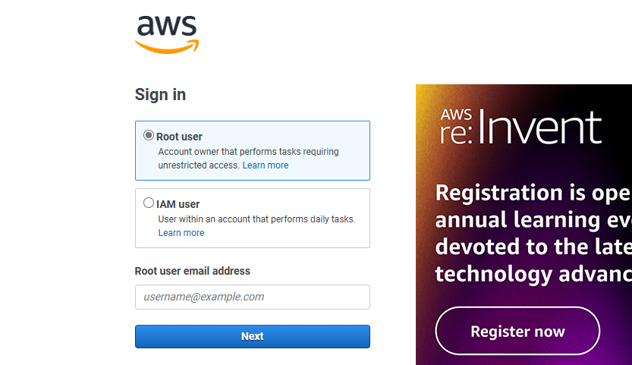

Serverless Image Processing Flow:

- User uploads a file to the source S3 bucket (which is used for storing uploaded images)
- When the image is uploaded to a source S3 bucket, it triggers an event which invokes the Lambda function. The lambda function processes the image.
- Processed image is stored in the destination S3 bucket.
- The processed image is requested by the user.

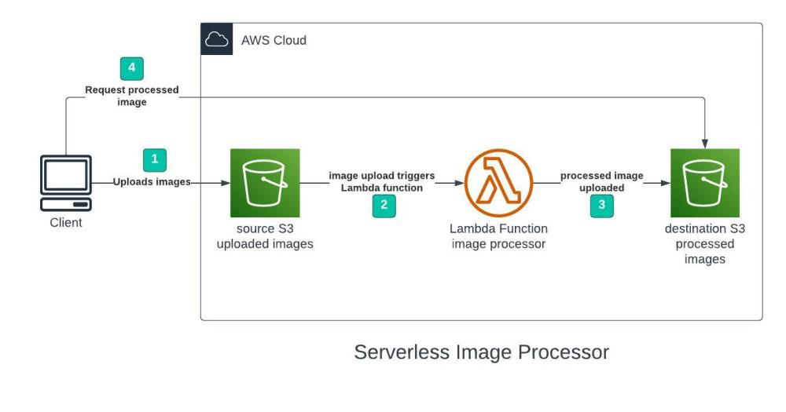

Step 2: Create an S3 Bucket

We will use two S3 buckets:

1. source Bucket: For storing uploaded images.
2. destination Bucket: For storing processed images.

Navigate to S3 Service:
In the search bar, type S3 and select the S3 service.
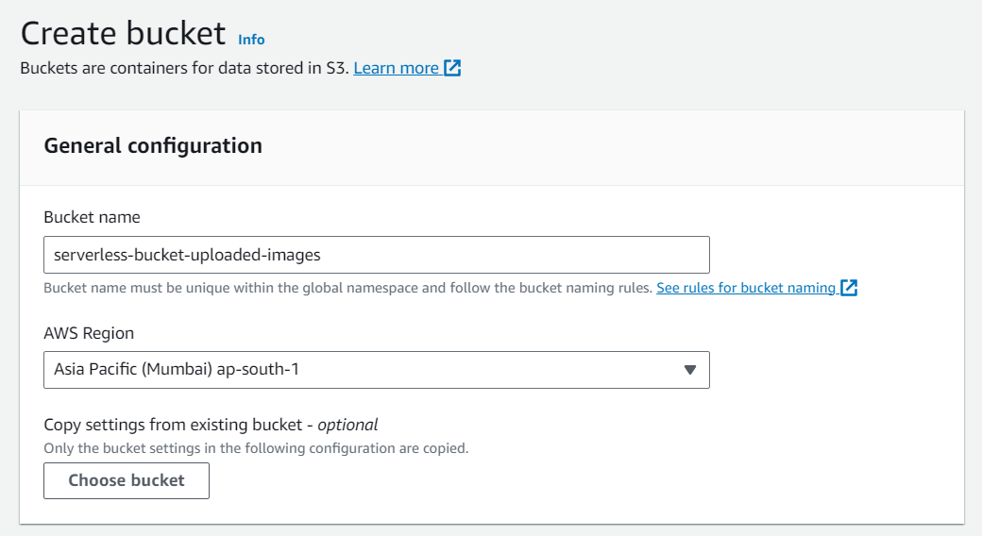
Create a New Bucket:
  - Click on Create bucket.
2. Provide a unique bucket name (e.g., my-website-bucket).
3. Choose the appropriate AWS region.
4. Leave the default settings and click Create bucket.
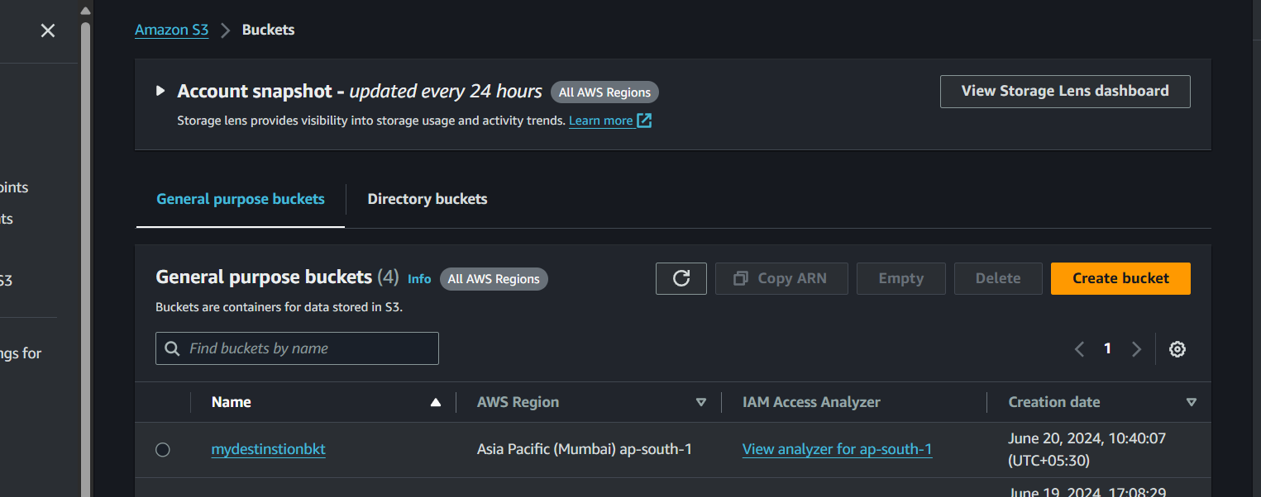

Step 3 – Creating Lambda function

- Go to AWS Lambda console.
- Navigate to Functions section.
- Click Create Function and name it “mydestinstionbkt”
- Select runtime as “NodeJS 18.x” and architecture as “x86_64”. Leave all other settings as default.

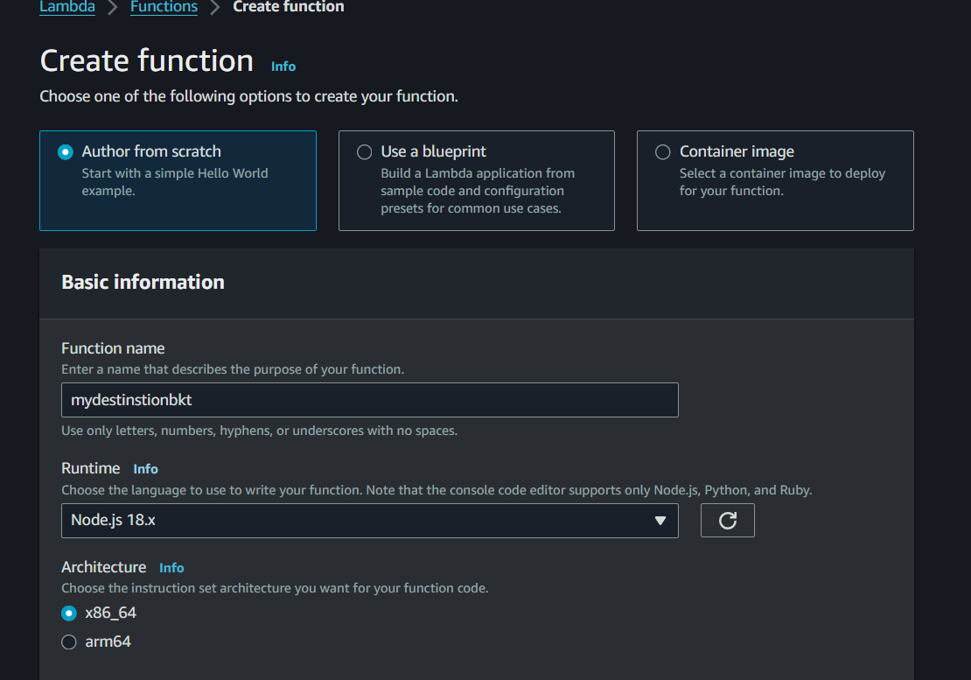

Node.js 18.x code:-

const sharp = require("sharp");
const path = require("path");
const AWS = require("aws-sdk");

Now go-to polices and create new polices in json and upload code.and code modify(like change bucket name place of source bucket and dest-bucket place use destination bucket).

Json code

{
"Version": "2012-10-17",
"Statement": [
{
"Effect": "Allow",
"Action": [
"logs:PutLogEvents",
"logs:CreateLogGroup",
"logs:CreateLogStream"
],
"Resource": "arn:aws:logs:*:*:*"
},
{
"Effect": "Allow",
"Action": ["s3:GetObject"],
"Resource": "arn:aws:s3:::mydestinstionbkt/*"
},
{
"Effect": "Allow",
"Action": ["s3:PutObject"],
"Resource": "arn:aws:s3::: mydestinstionbkt/*"
}
]
}

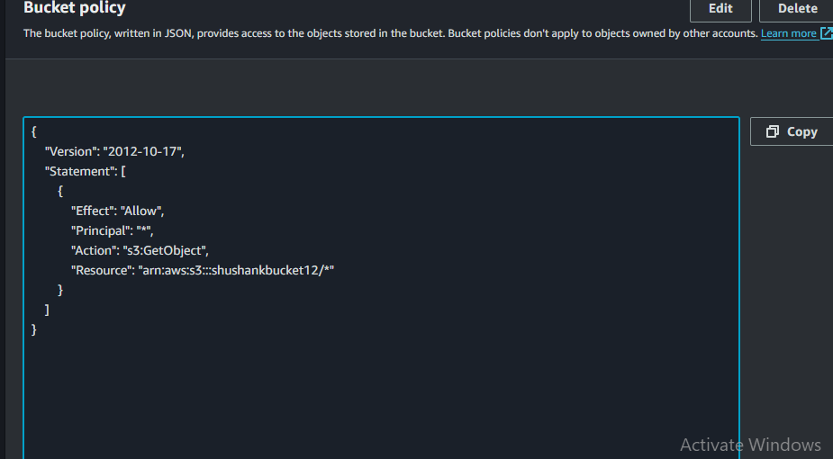
Click Next

- Now give the policy name and click create policy.

- Go-to the IAM and create a new role and select lambda and click next.

- Select policy click next.

- Give role name create role.

- And now select use an existing role in change default excution role and select our role and click create function.

- Add trigger

- Select s3

- Give source bucket in bucket option.

- Check acknowledge and further no change click add.

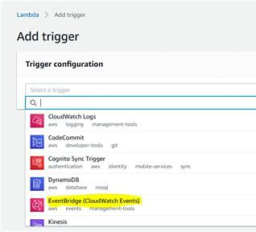

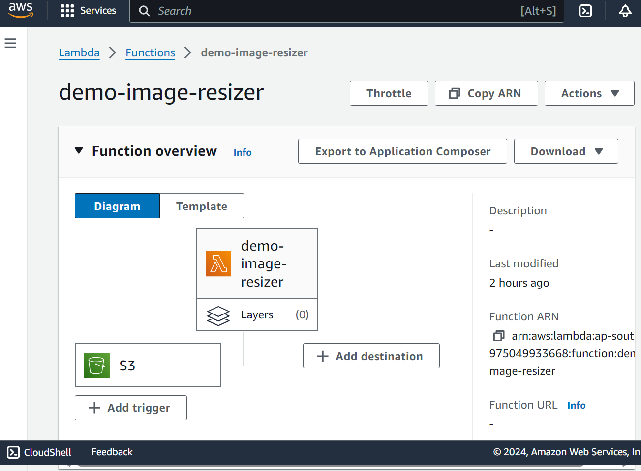

Environment Variable

- This option is available in configure section.

- Edit Environment Variable

- Key shushankbucket12 and value your destination bucket.

- Save

- Now go-to the Test option and select s3-put option.(modify code source-bucket place of exemple-bucket and upload file are used in key).

- And Test it.

- Source bucket.

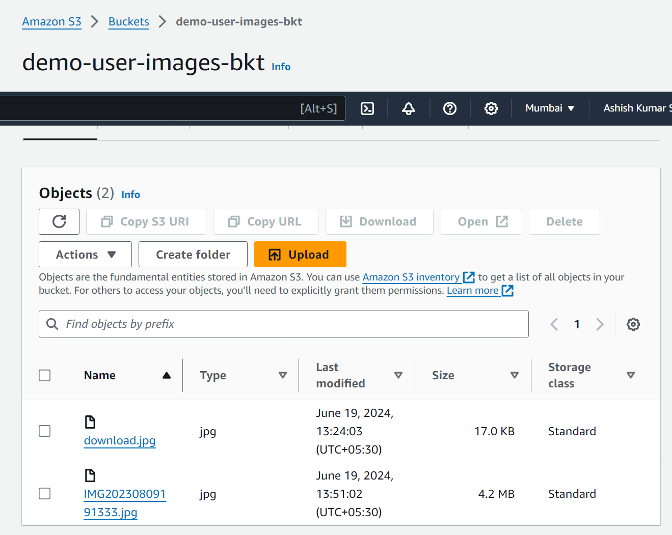

- Go-to the destination bucket and check your image are resize.

